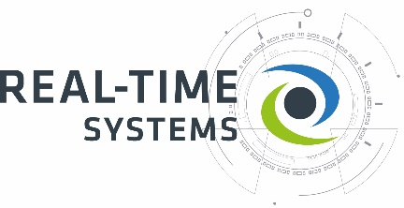
Press release

Real-Time Systems acquires Arendar IT-Security

Expanded edge computing portfolio to include secure IoT connectivity ‘Made in Germany’

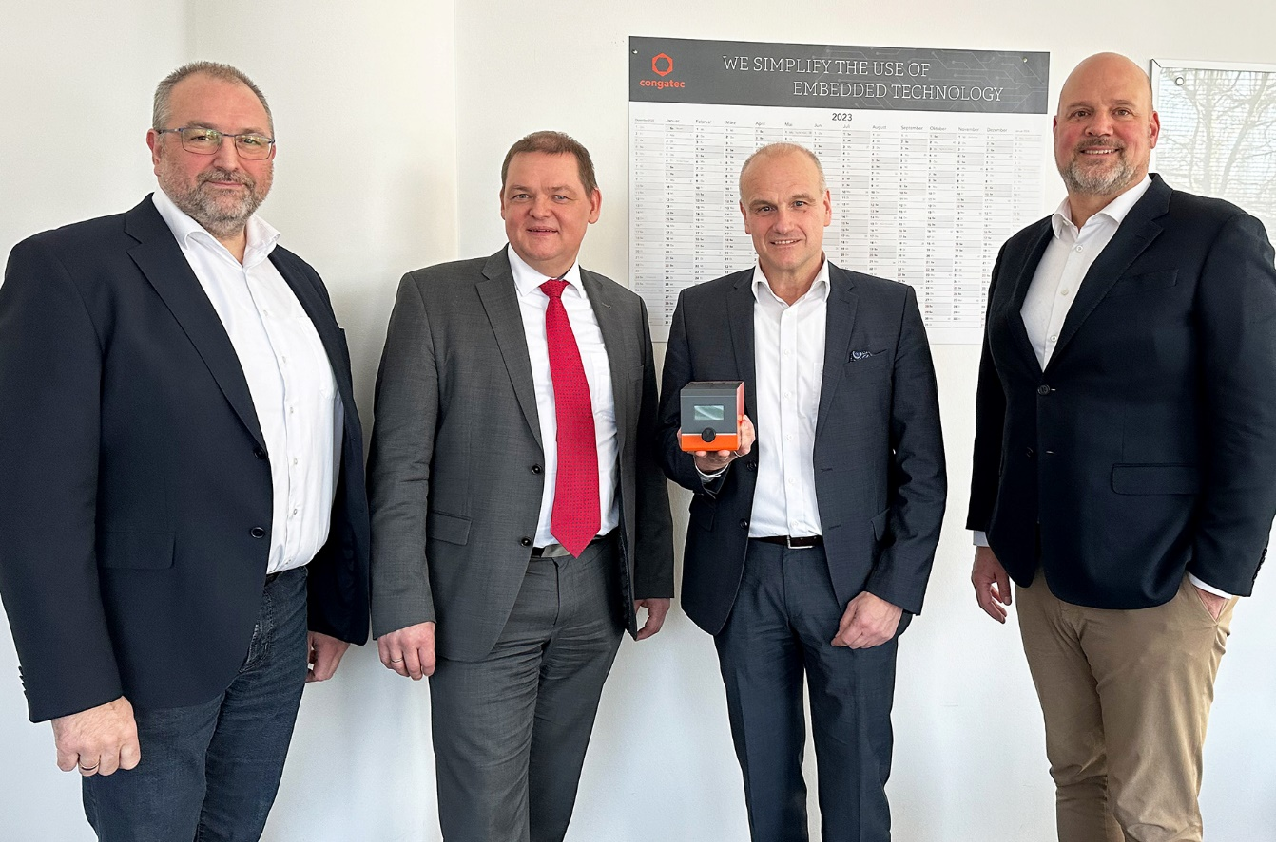
Konrad Garhammer (Managing Director of congatec Group), Rudolf Preuß (Managing Director Arendar IT-Security), Jürgen Kreis (Director Of Sales And Business Development Arendar IT-Security), and Daniel Jürgens (Managing Director of congatec Group) (from left to right) are happy to open up the Arendar offering to OEMs worldwide

Ravensburg, Germany, 8 February 2023 * * * Real-Time Systems (RTS) – a global provider of hypervisor technology and part of the congatec Group – has acquired Arendar IT-Security GmbH to expand its service portfolio, which will now include edge computing for secure OT/IT connectivity for the digitization of industrial machines, plants and processes. For RTS, this signifies a step towards a solution-oriented offering for OEMs and end users. The Arendar portfolio comprises IoT gateway solutions including edge and cloud middleware as well as software engineering services for the holistic digitization of industrial processes within systems and plants. Arendar has primarily been serving manufacturing companies in Germany. Acting as part of the global congatec Group, Real-Time Systems will now open up the Arendar offering to OEMs worldwide, which promises significantly higher economies of scale. The newly acquired solution portfolio will be presented to the broad trade audience for the first time at embedded world 2023.

“The solution and service portfolio of Arendar IT-Security is an excellent fit with our strategic positioning in the industrial automation and communications infrastructure market, where more and more data needs to be exchanged securely as a result of digitization,” explains Konrad Garhammer, Managing Director of congatec Group.

“We particularly wish to expand our IoT connectivity expertise because of the ever-increasing cybersecurity requirements. Together with the hypervisor technology of our subsidiary Real-Time Systems, we are now in a position to support our customers’ digital transformation with sustainable solution modules bearing the trustworthy ‘Made in Germany’ seal,” adds Daniel Jürgens, Managing Director of congatec Group.

Together, RTS hypervisor technology and the highly standardized embedded and edge computing ecosystem of the congatec Group provide an excellent foundation for embedding Arendar IT-Security's solution portfolio into OEM and end-user applications. In sum, this creates a holistic solution for the digitization of industrial machines, plants and processes. Typical use cases of the Arendar portfolio include: reading data from PLCs, fieldbuses, and sensors, including universal protocol translation for unified communication; remote control and maintenance of systems; plant visualization in the cloud; creation of OT added value through horizontal IoT integration of multiple devices, machines and plants in collaborative clouds; and connectivity between business IT and OT – all protected against IP theft or sabotage by high cybersecurity.

* * *

About Real-Time Systems
Real-Time Systems is a global provider of hypervisor technology and specializes in real-time virtualization. The Intel® Co-Development Partner was founded in 2006 and is headquartered in Ravensburg, Germany. Since 2018, Real-Time Systems GmbH has been an independent congatec Group member with partners in Europe, the USA and Asia.
Today, Real-Time Systems offers a real-time hypervisor (RTS Hypervisor) and a hypervisor addressing functional safety and cybersecurity (RTS Safe Hypervisor) on x86 hardware architecture.
More information is available on our website at www.real-time-systems.com or via LinkedIn and YouTube.

About Arendar IT-Security GmbH
Arendar IT-Security GmbH was established as a subsidiary of AREND in Wittlich, Germany, in 2019. The company provides digitization, IT/OT/Cloud connectivity and data collection solutions that are based on the proprietary ARENDAR platform – a solution portfolio comprising hardware and middleware for the holistic digitization of industrial processes within systems and plants. In addition, ARENDAR offers customer-specific services such as dedicated website creation, consultancy around OT connectivity, and the provision of Internet services. In November 2022, the company had to file for insolvency. In the course of the insolvency proceedings that opened on 1 February 2023, Real-Time Systems has now acquired Arendar IT-Security.

Reader enquiries:
Real-Time Systems GmbH
Phone: +49 751 359 558-0
info@real-time-systems.com
www.real-time-systems.com

Press contact Real-Time Systems:
Christof Wilde
Phone: +49-991-2700-2822
christof.wilde@real-time-systems.com

Press contact PR agency:
SAMS Network
Michael Hennen
Phone: +49-2405-4526720
rts@sams-network.com
www.sams-network.com

Please send print publications to:
SAMS Network
Sales And Management Services
Michael Hennen
Zechenstraße 29
52146 Würselen
Germany

Please send links to digital publications to:
office@sams-network.com

