Reader enquiries:  Real-Time Systems GmbH  Jürgen Malin  Tel.: +49 751 359 558-0  info@real-time-systems.com  www.real-time-systems.com | Press contact:  SAMS Network  Michael Hennen  Tel.: +49-2405-4526720  info@sams-network.com  www.sams-network.com

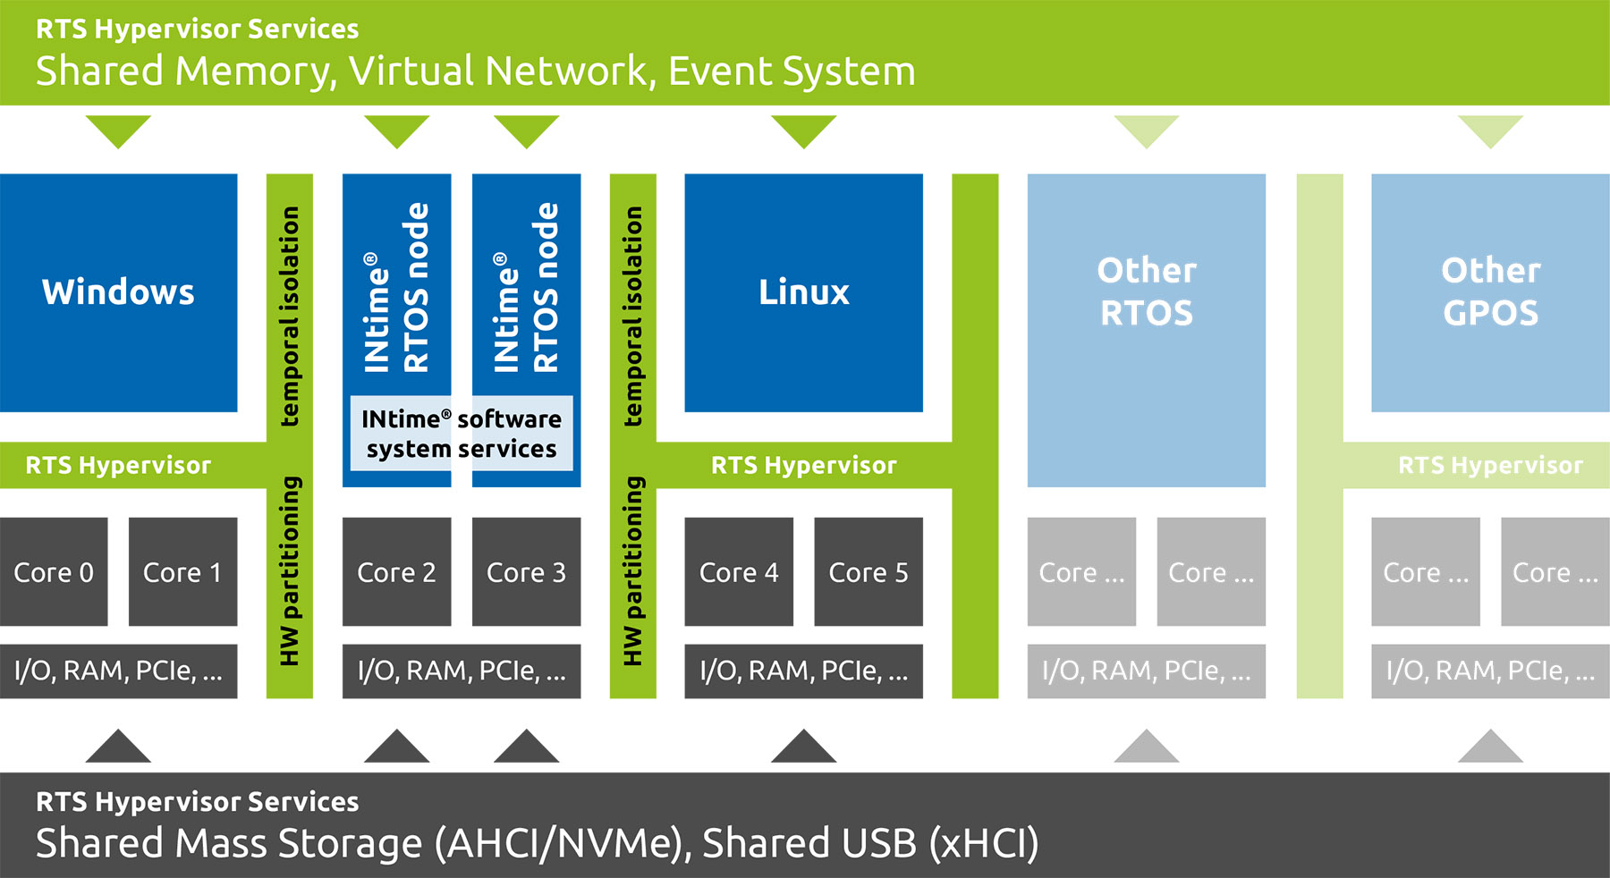
Text and photograph available at: https://www.real-time-systems.com/news.html
Press release
RTS Hypervisor: Full support for INtime® RTOS
TenAsys® and Real-Time Systems team up to greatly improve
secure system consolidation and determinism

Ravensburg, Germany, 17 December 2020 * * *
TenAsys®, experienced provider of real-time operating system software and services, teams up with Real-Time Systems GmbH (RTS), a recognized Intel® co-development partner for hypervisor technology. This strategic partnership results in an exceptionally versatile PC-based software platform for a secure, consolidated system of disparate workloads addressing strict deterministic application needs.

Flexible consolidation with hard real-time
The out-of-the-box RTS Hypervisor for x86 architecture unlocks the full potential of today’s multicore processors. It enables TenAsys’ INtime® RTOS applications to run alongside a wide spectrum of different operating systems and varying workloads – in hard real-time at minimum jitter, avoiding any overhead from virtualization. The software platform allows designers to make use of the latest protocols and CPU technologies like Time-Sensitive Networking (TSN) or Intel® Time Coordinated Computing (TCC). Besides enhancing system performance and reducing total system power consumption, a consolidated system solution increases flexibility in communication and enables shared use of USB, NVMe, and AHCI devices.

Security without compromises
INtime® distributed RTOS has been paravirtualized to operate within the RTS Hypervisor. The hardware-assisted virtualization technology securely shields real-time applications from other operating systems. This not only greatly improves security; it also allows to reboot general-purpose operating systems while real-time applications on INtime keep running during the process.

“INtime® for Windows has been one of the most popular Windows real-time environments for many years. With INtime® Distributed RTOS support in our solution, even more designers around the globe can now benefit from the RTS Hypervisor, which is developing more and more into the de facto standard for industrial automation and medical applications,” stated Gerd Lammers, founder of Real-Time Systems.

For qualified applicants, Real-Time Systems and TenAsys® provide a pre-integrated evaluation version free of charge.

More information regarding the partnership and the benefits of the solution can be found at www.real-time-systems.com/intime-distributed-rtos

About TenAsys®
TenAsys® was founded in 2000 and provides real-time software and services based on the Intel® x86 architecture and Microsoft Windows. The company’s solutions have proven themselves on mission-critical systems in diverse fields for decades. TenAsys® is present in all major technological geographies worldwide.
More information is available on the website at www.tenasys.com

About Real-Time Systems
Real-Time Systems is a global provider of hypervisor technology specializing in real-time virtualization. The Intel® co-development partner was founded in 2006 and is headquartered in Ravensburg, Germany. Since 2018, Real-Time Systems GmbH is a company of congatec AG with partners in Europe, USA, and Asia.
More information is available on our website at www.real-time-systems.com or via LinkedIn and YouTube.

